


FPT ACADEMY INTERNATIONAL

FPT – APTECH COMPUTER EDUCATION

GIFT SHOP

Center Name |  | FPT – Aptech – HCM2  Address: 590 Cach Mang Thang Tam, District 3, Ho Chi Minh City
Instructor |  | Ms. Le Mong Thuy
Class |  | T1.2104.E0
Group |  | 2
Group members |  | Name | Student ID
 |  | Đỗ Thành Ân | Student1316200
 |  | Nguyễn Hoàng Tuấn | Student1313762
 |  | Phạm Quang Ngọc Thạch | Student1313749
Duration | Start date | 14th July 2021
Duration | End date | 14th Aug 2021

This is to certify that

Mr.:

Đỗ Thành Ân

Nguyễn Hoàng Tuấn

Phạm Quang Ngọc Thạch

has successfully designed & developed

eProject: Gifts Shop website

Submitted by:

Đỗ Thành Ân

Date of issue:
15th July 2021

Authorized Signature:


TABLE OF CONTENTS
FPT-APTECH COMPUTER EDUCATION 1
ACKNOWLEGMENT 3
SYNOSIS 3
PROBLEM DEFINITION 3
CUSTOMER’S REQUIREMENTS SPECIFICATION (CRS) 4
Business/project Objective 4
Hardware/software Requirements 5
SCOPE OF THE WORK (IN BRIEF) 6
Architecture and design of the system 7
Diagram of website 8
TASK SHEET REVIEW 1 9
SITE MAP 10
MOCK OF THE WESITE 11
1. Home page 11
2. Shop 12
3. Features 13
4. Gallery 14
5. Logo 15
6. About us 16
7. Contact us 17
8. Member 18
TASK SHEET REVIEW 2 19
WEBSITE DISCRIPTION 20
1. Home page 20
2. Shop 21
3. Product categories 21
4. Features 22
5. Gallery 23
6. About us 24
7. Contact us 25
8. Member 26
JAVASCRIPT DISCRIPTION 27
1. Product data json and javascript 27
2. Filter javascript 30
3. Comparison javascript 31
4. Add to cart javascript 34
5. Contact us javascript 35
TASK SHEET REVIEW 3 36

ACKNOWLEGMENT

On behalf of all the members of group 2, I would like to thank you all for the hard works, supports to make this eProject complete successfully. Especially, Ms. Le Mong Thuy, our teacher, she helped us a lot from the day that we started to study at FPT Aptech. With this eProject, she has guided us with her enthusiasm and rigorous, because of her guiding, we would be able to finish this project. Besides, I want to thank all the team member of group 2, each of the team member has been working continuously in 4 weeks in order to complete this project. The last but not least, we would like to say thank you to our family for always supporting us, creating the best conditions for us to focus on the project, and putting faith in the dreams we pursue.

SYNOSIS

In this task, we are assigned to design and develop a business website which meets all the requirements from our client under the name Gift. The business is all about selling gift items such as mugs, cards, bracelets, necklace and various gift items. Client's goal for the website is to bring convenience to customers who can easily View their products in detail and those are currently available. Beside, the business also offer some seasonal events which they wish to display on the website for customers.

PROBLEM DEFINITION

GIFTS is selling various types of Gift Items. The company advertises by distributing the pamphlets, advertising on television and so on. Due to rapid development in internet field, the company decides to launch a website where people will get all the information about the various products available with them easily. You are supposed to create a website for them with the below mentioned requirement specifications.
The website is to be developed for the Windows Platform using HTML5, JavaScript and Geolocation. The site should work well in all leading browsers including Chrome, IE, Firefox etc.

CUSTOMER'S REQUIREMENTS SPECIFICATIONS (CRS)

Client: Gift Shop

Business/Project Objective:

GIFT is selling various types of Gift Items. The company advertises by distributing the pamphlets, advertising on television and so on. Due to rapid development in internet field, the company decides to launch a website where people will get all the information about the various products available with them easily. You are supposed to create a website for them with the below mentioned requirement specifications.
The website is to be developed for the Windows Platform using HTML5, JavaScript and Geolocation. The site should work well in all leading browsers including Chrome, IE, Firefox etc.

Input to the system:

- Searching products of gift item: mugs, clocks, perfumes, stuffed animals, jelwery accessories.

Output from the system:

- A menu that will categorize all the functions of the site.
- Display the list of available gifts category wise.
- Perform the search based on a particular: mugs, perfurme, jewelry accessories, stuffed animals, clock.
- Display the best seller monthly.
- Display the various offers by the shop.
- Display the details of item (brand, material, price, etc.).
- Give information about product.
- Site should be able to provide brief infomation of business(history, country, members...).
- The location of the shop under Contact-Us page.
Progress:
- In the Shop site, users can use filter to sort type of products.
- We allow user to select and compare product in specific categories.

Expected delivery date: 14th-August-2021.

List of deliverables:

      - Document Word.
      - Source code.

Hardware/ Software Requirements:

- For developer
Hardware
  - Intel Pentium 4 processor or higher
  - 1 Gigabytes of RAM or higher
Software
  - Windows 7 OS or higher
  - Adobe Dreamweaver
  - Web browsers such as IE, Chrome or Firefox are supporting HTML5, CSS3 and Javascript.

- For web users
Hardware
  - Intel Pentium 4 processor or higher
  - 512 Megabytes of RAM or higher
Software
  - Windows XP OS or higher
  - Web browsers such as IE, Chrome or Firefox are supporting HTML5, CSS3 and Javascript.

SCOPE OF THE WORK (IN BRIEF)

After a long and detailed discussion, our group has decided to create a website contain the following webpages:

- Homepage: We divided the section into 3 parts:
    - Part 1: Display section in carousel/slides: new arrivals/promotion/seasonal event.
    - Part 2: Display menu best seller items.
    - Part 3: Customer Feedback (display images)

- Shop: Display all items, compare and filter to sort items in specific categories and brands.

- Features: Display downloadable documents (manual/visual instruction) or display embedded video on page.

- AboutUs: Display business information and client review (persuasive reasons to choose our business).

- Contact: Display business contacts (address, phone, email, map).

Architecture and design of the system





Webpage request
Requested Page
RENDERING
ENGINE
CSS CODE
HTML CODE
WEB SERVER
WEB BROWSER
CLIENT
SERVER

Diagram of the website

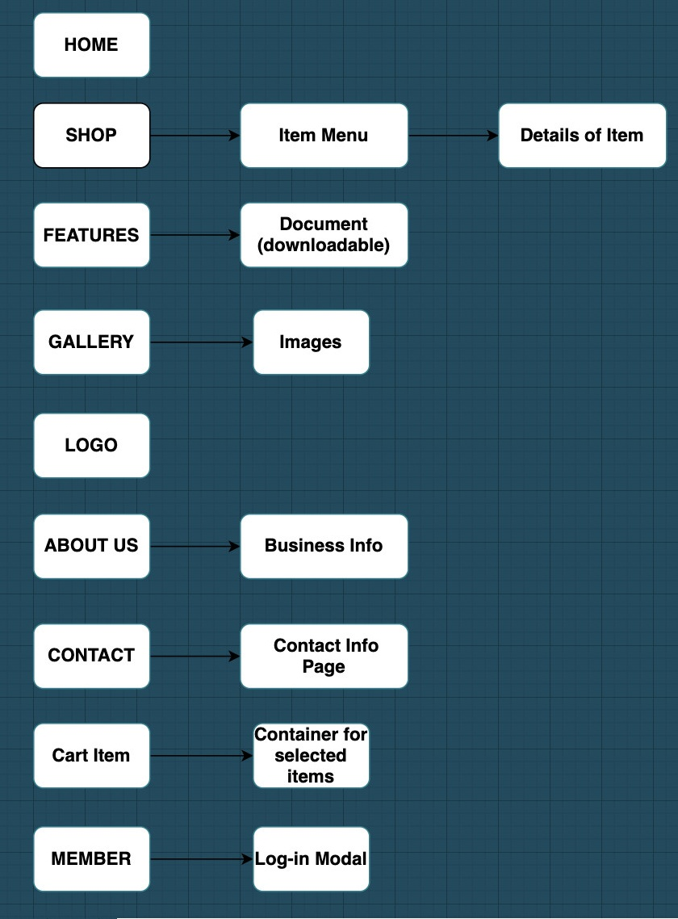







TASK SHEET REVIEW 1

Project Ref. No.:  eP/Advertisement Portal Management  System/01 |  | Project Title: | Activity Plan Prepared By: | Date of Preparation of Activity Plan:
Sr.  No. | Task | Project Title: | Activity Plan Prepared By: | Actual  Start Date | Actual Days | Team Mate Names | Status
1 | Problem Statement | GIFTS SHOP | Đỗ Thành Ân | 15-July-21 | 1 | Đ.T.Ân | Completed
2 | Analysis of Gifts Shop requirements about the website | GIFTS SHOP | Đỗ Thành Ân | 15-July-21 | 1 | P.Q.N.Thạch | Completed
3 | The scope of the work (in brief) | GIFTS SHOP | Đỗ Thành Ân | 15-July-21 | 1 | P.Q.N.Thạch | Completed
4 | Architecture and design of the system | GIFTS SHOP | Đỗ Thành Ân | 15-July-21 | 1 | N.H.Tuấn | Completed
5 | Diagram of the website | GIFTS SHOP | Đỗ Thành Ân | 15-July-21 | 1 | N.H.Tuấn | Completed
6 | Task Sheet | GIFTS SHOP | Đỗ Thành Ân | 15-July-21 | 1 | Đ.T.Ân | Completed

Date: 15th July 2021
Signature of Instructor:  Ms. Le Mong Thuy | Signature of Team Leader:  Do Thanh An

SITE MAP

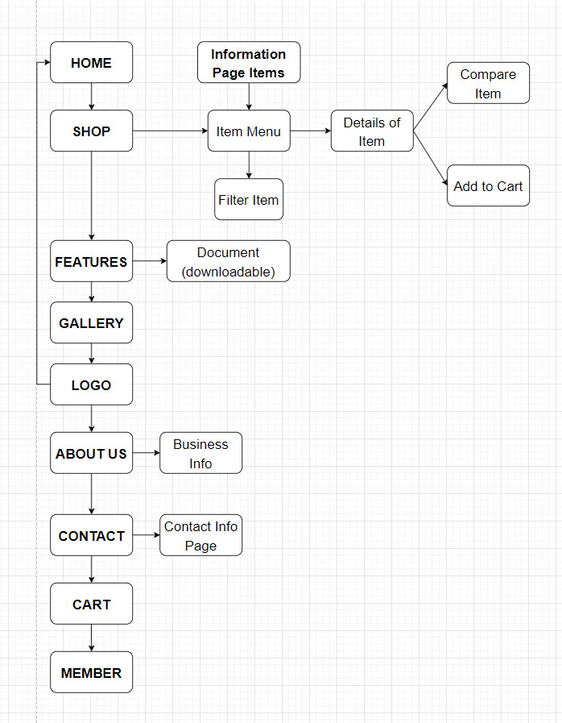

MOCK OF THE WEBSITE

- Homepage

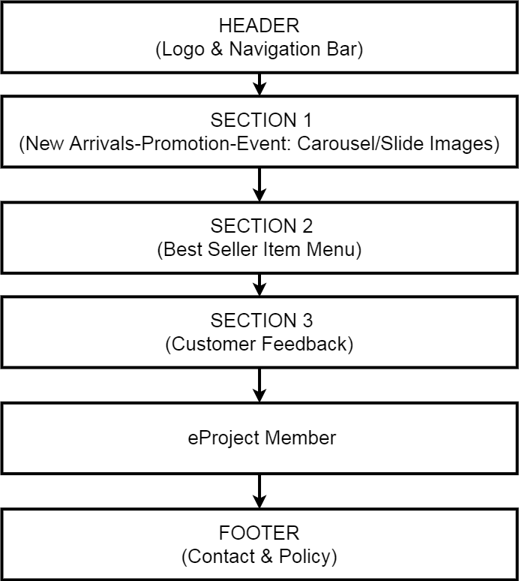

- Shop

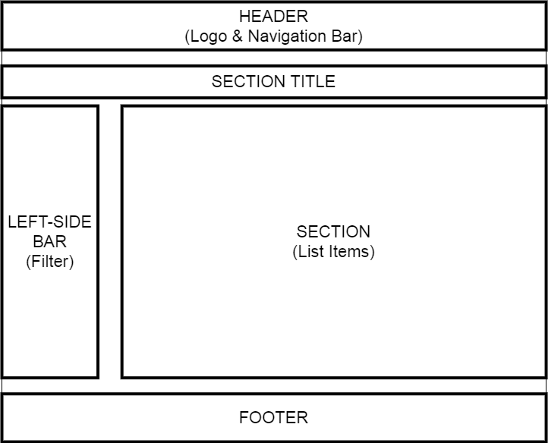

- Features

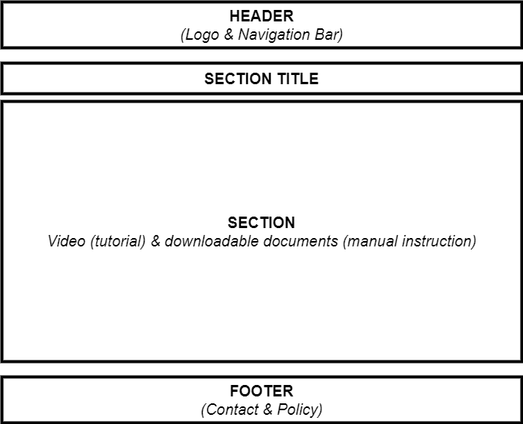

- Gallery

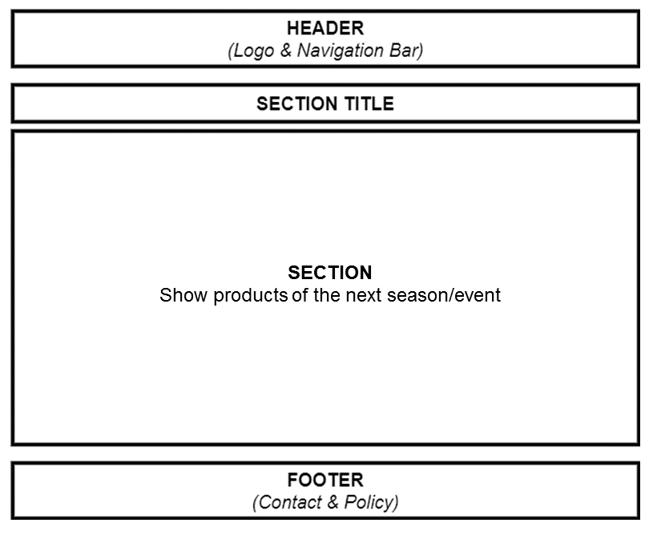

- Logo

This logos designed by Nguyễn Hoàng Tuấn-Student1313762

HEADER LOGO (BLACK)


FOOTER LOGO (WHITE)


- About us

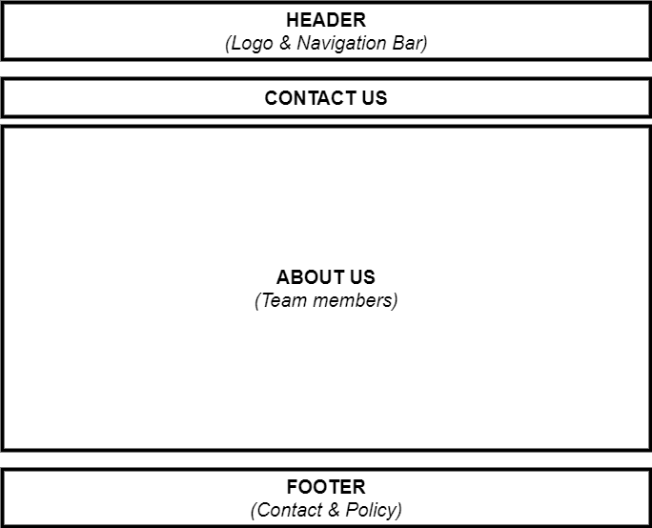

- Contact us

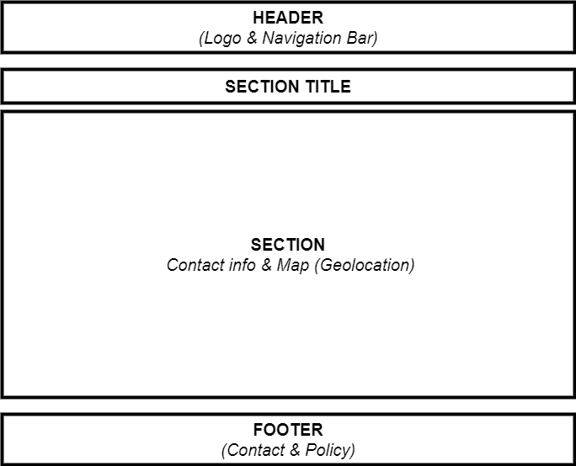

- Membership
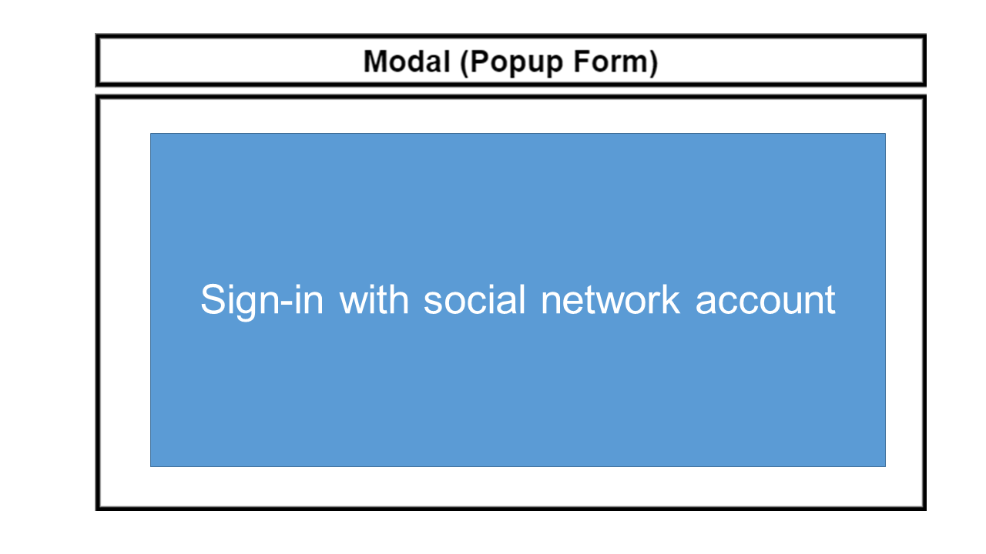

TASK SHEET REVIEW 2

Project Ref. No.:  eP/Advertisement  Portal Management System/01 |  | Project Title: | Activity Plan Prepared By: | Date of Preparation of Activity Plan:
Sr.  No. | Task | Project Title: | Activity Plan Prepared By: | Actual Start Date | Actual Days | Team Mate Names | Status
1 | Site map | GIFT  SHOP | Đỗ Thành Ân | 16th-July-2021 | 1 | P.Q.N.Thạch | Completed
2 | Mock of the website | GIFT  SHOP | Đỗ Thành Ân | 16th-July-2021 | 2 | N.H.Tuấn | Completed
3 | Task sheet | GIFT  SHOP | Đỗ Thành Ân | 16th-July-2021 | 2 | Đ.T.Ân | Completed

Date: 19th July 2021
Signature of Instructor:  Ms. Le Mong Thuy | Signature of Team Leader:  Do Thanh An

WEBSITE DESCRIPTION

- Home page
- Description
Home page displays following infomation
    - Events
    - Best Seller
    - Feedbacks
  - Screenshot

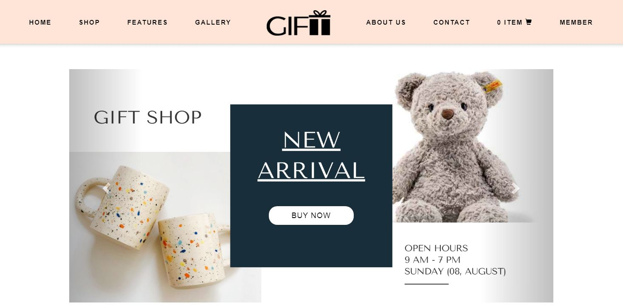
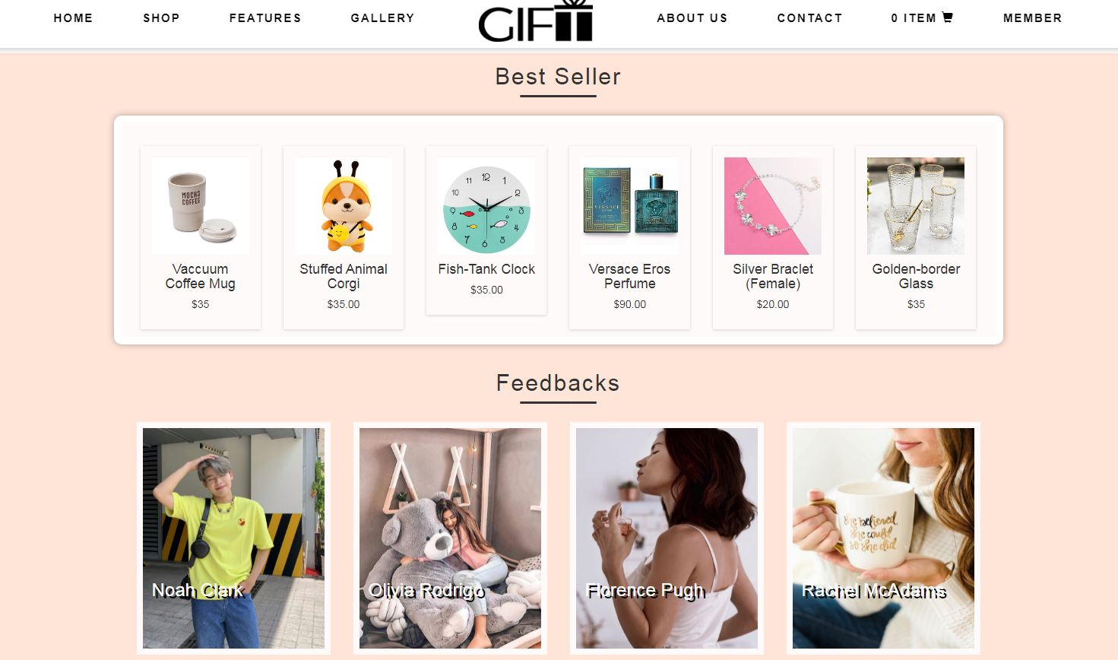
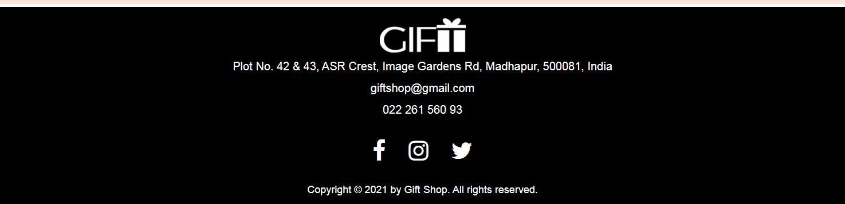

- Shop
  - Description
Shop page displays following infomation
    - Show all products at Shop page.
    - Show all product categories:
+ Mug.
+ Jewelry
+ Clock
+ Stuffed animal
+ Perfume
  - Screenshot

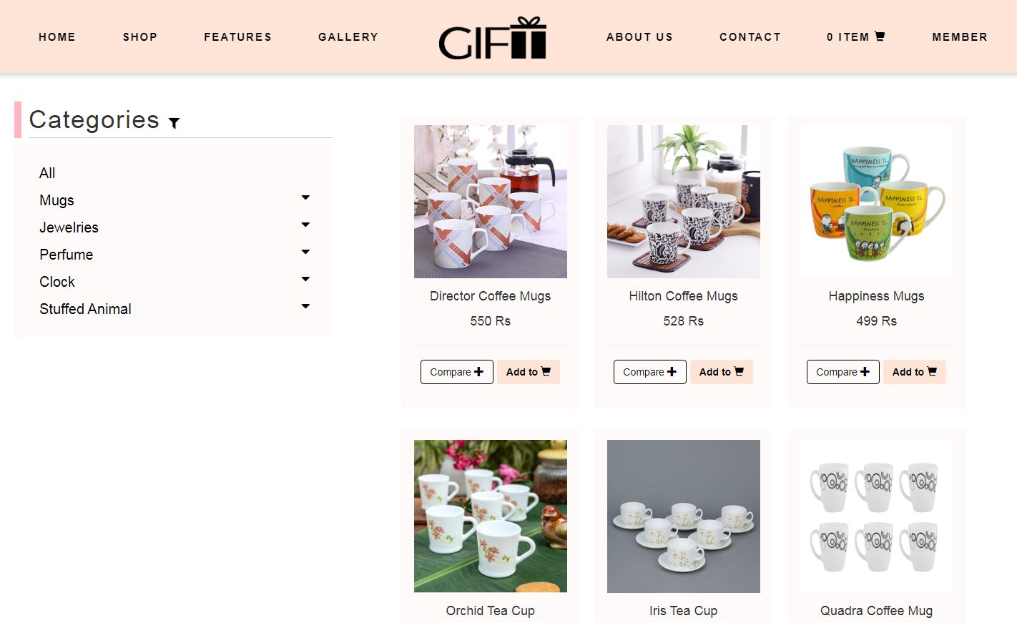

- Product categories
  - Description
Product category pages displays following infomation
    - Show all products of category.
    - Filter by brands and categories.
  - Screenshot

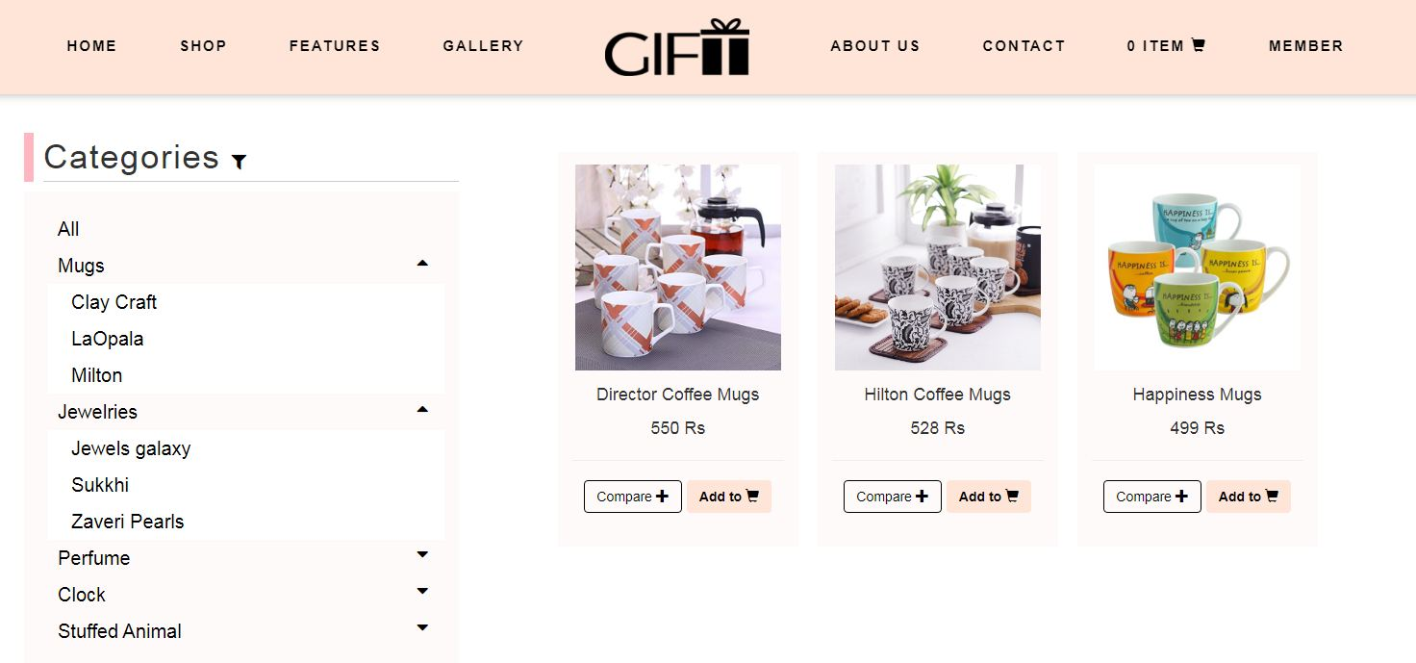

- Featuers
  - Description
This page displays a brief summary of features of individual products.
  - Screenshot

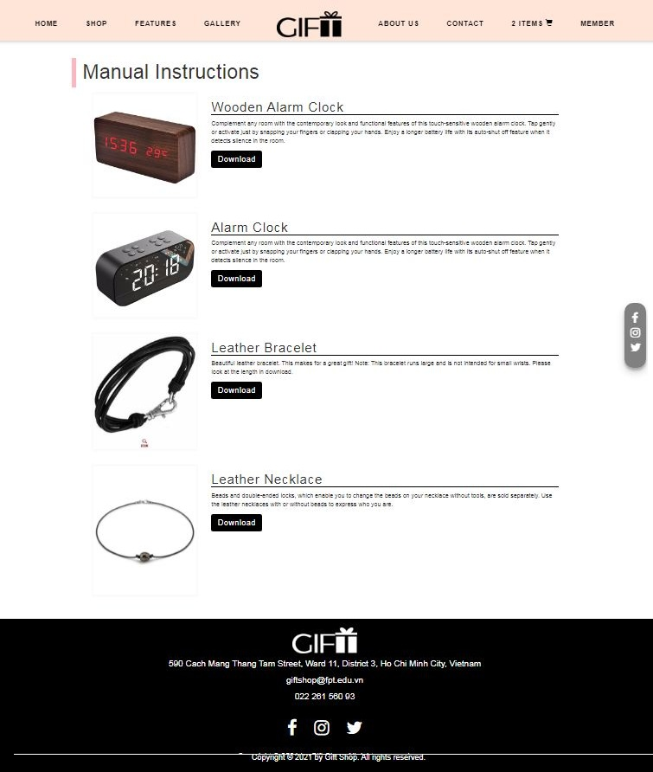

- Gallery
  - Description
This page will displays information about new products of the next season/event.
  - Screenshot

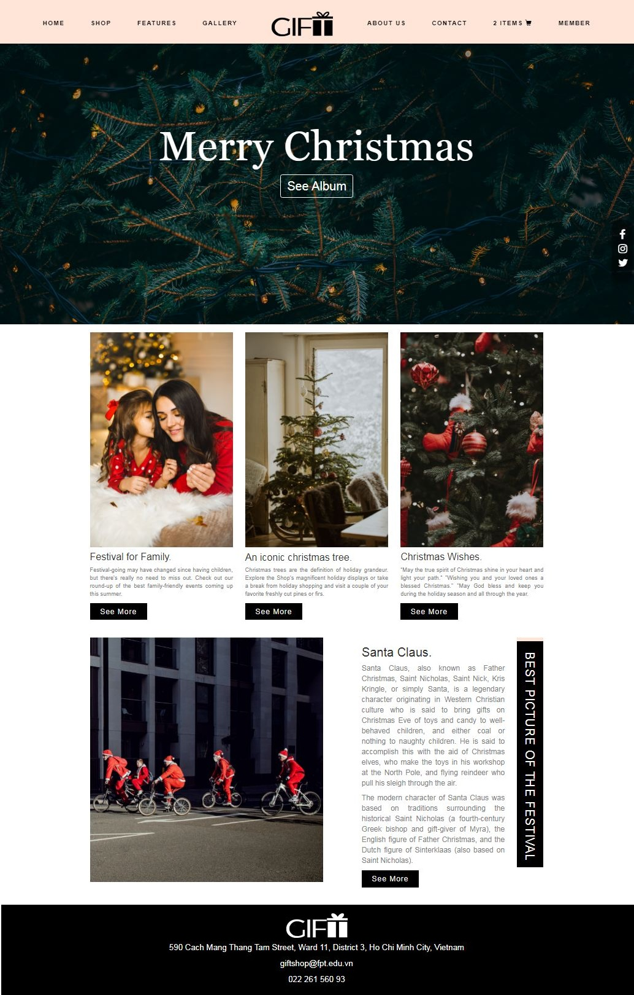

- About us
  - Description
This page will displays information about the history of Gift shop, our service that we provide and our team member.
  - Screenshot

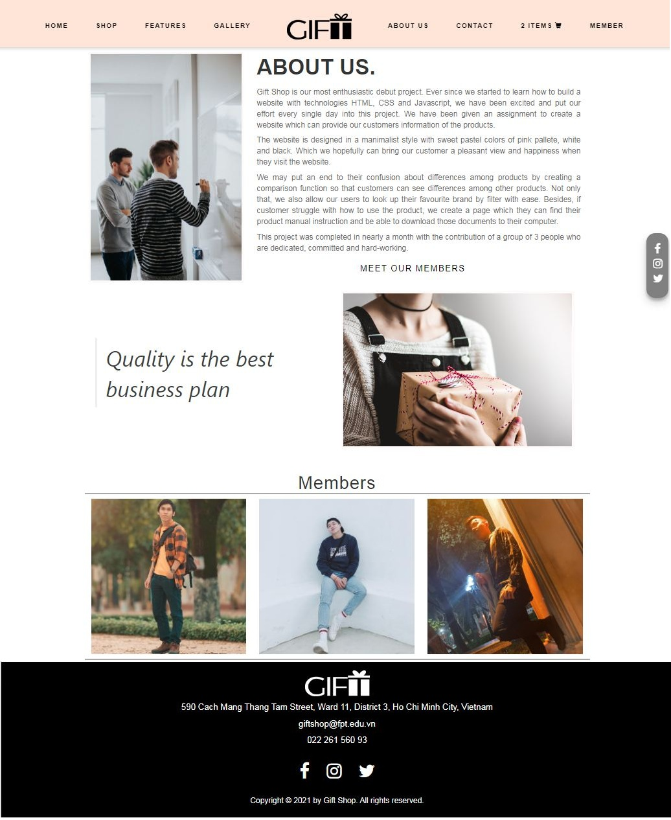

- Contact us
  - Description
This page displays contact information: location, telephone number, email and a quick contact form for customer.
  - Screenshot

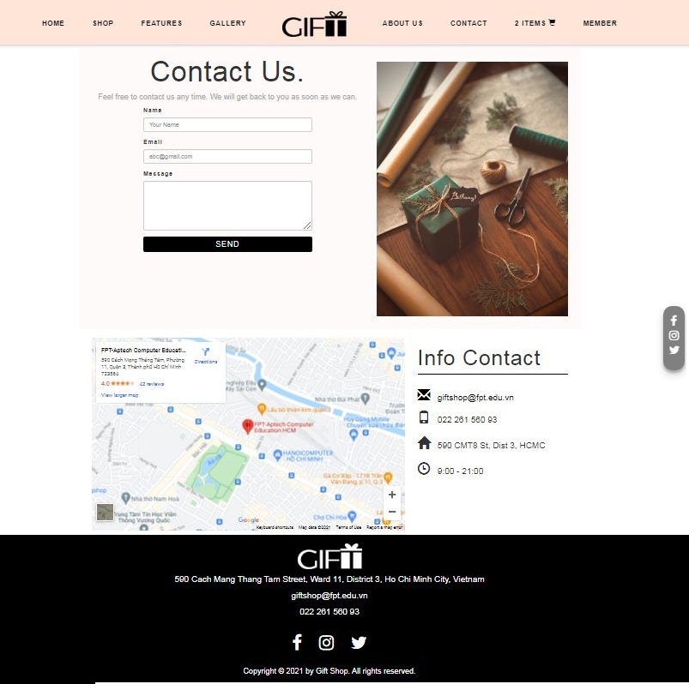

- Member
  - Description
This modal displays 2 types of login:
- Login with account which registed directly at local shop.
- Login with social network account.
  - Screenshot

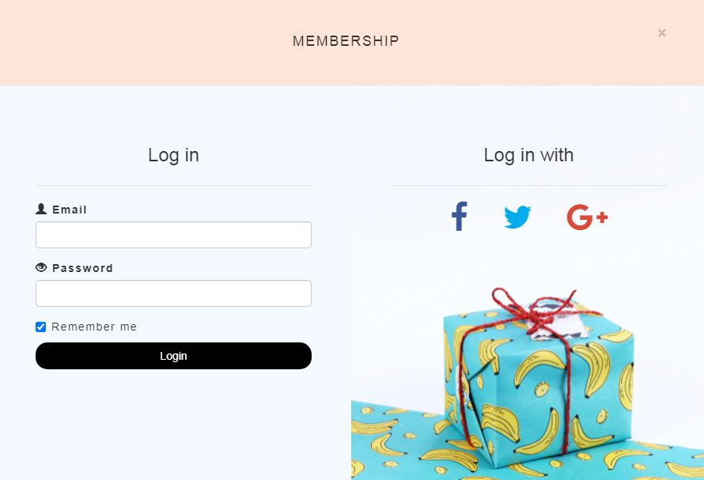

JAVASCRIPT DESCRIPTION
- Product data json and javascript.
  - Description
This script used for adding product detail.
  - Screenshot

b-1 Product data json

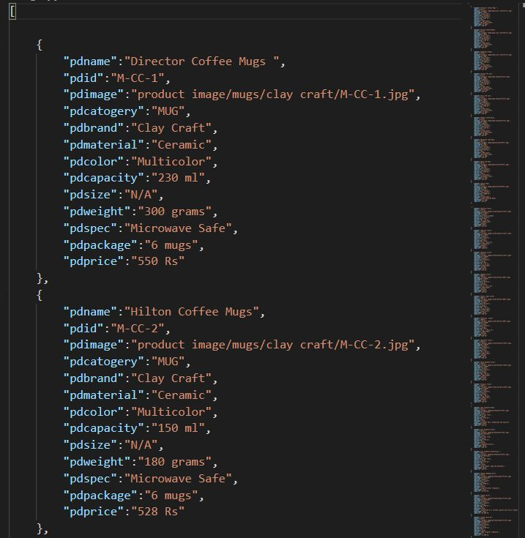

b-2 Javascript

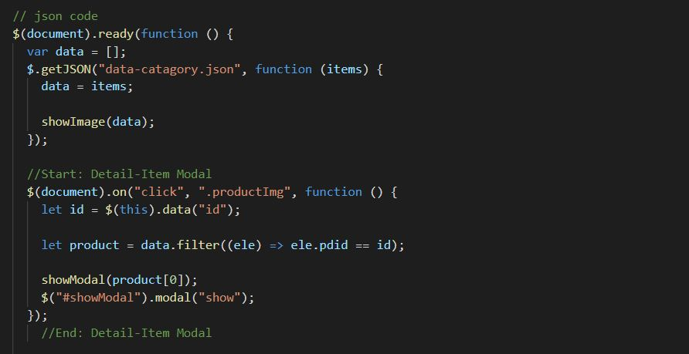
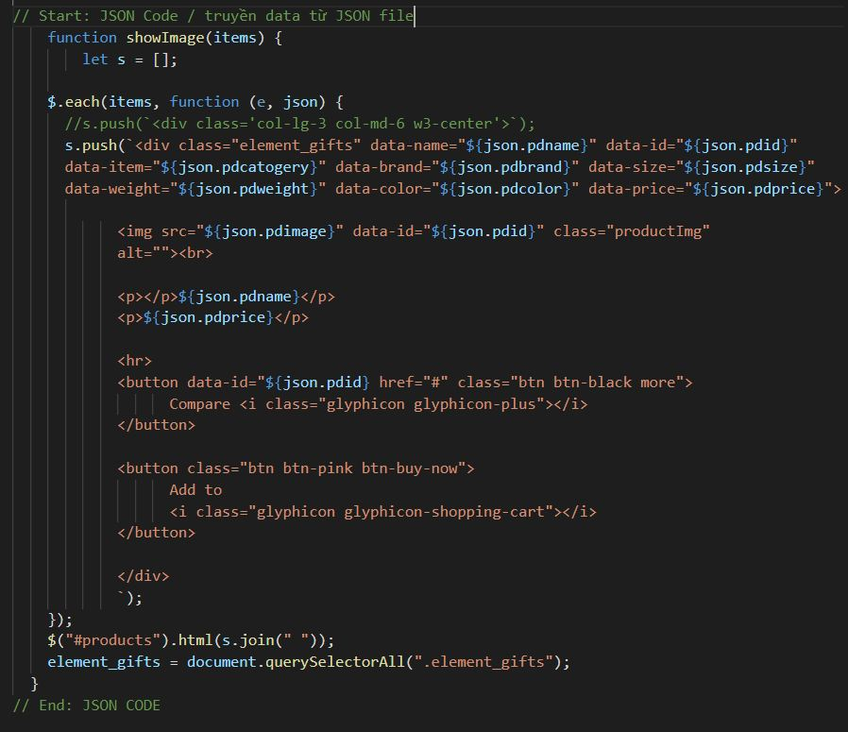

b-3 Modal show item’s detail

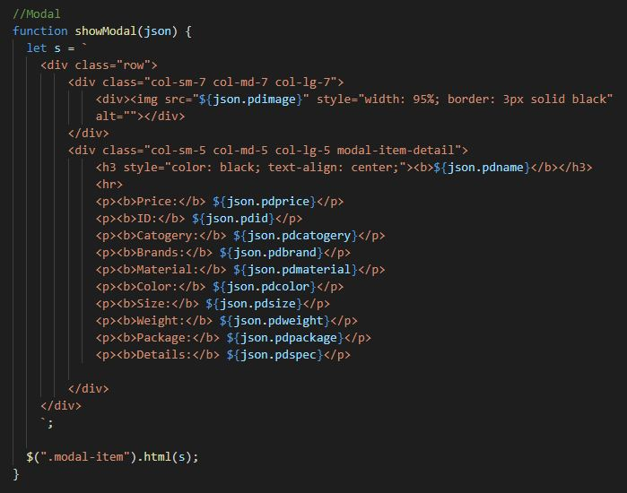

- Filter javascript
  - Description

This script used for filtering items in the shop page based on categories and brands
  - Screenshot

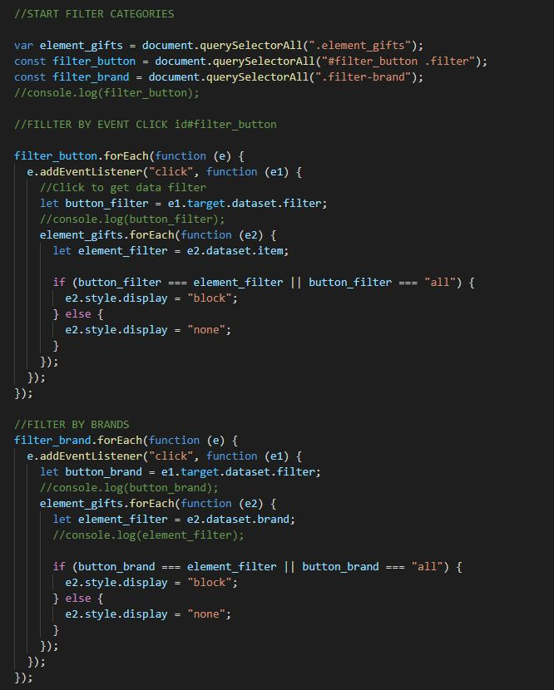

- Comparison javascript
  - Description

This script used for comparing items in the shop page based on categories and brands
  - Screenshot

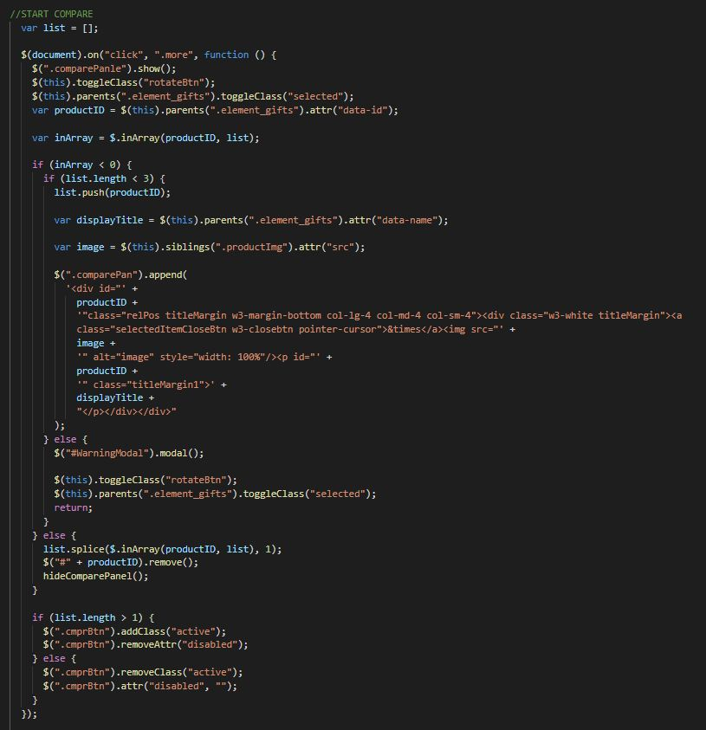

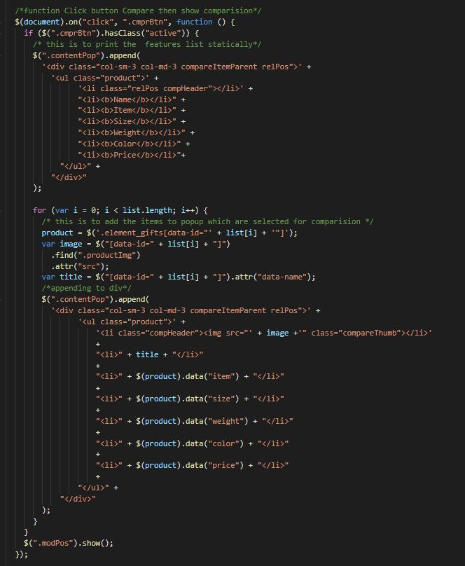

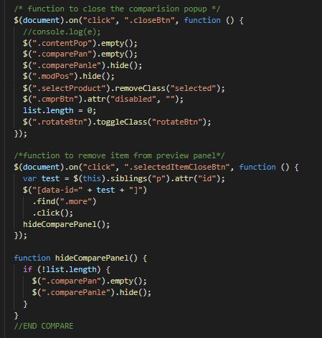

- Add to Cart javascript
  - Description

This script used for adding items to cart and show how many item added.
  - Screenshot

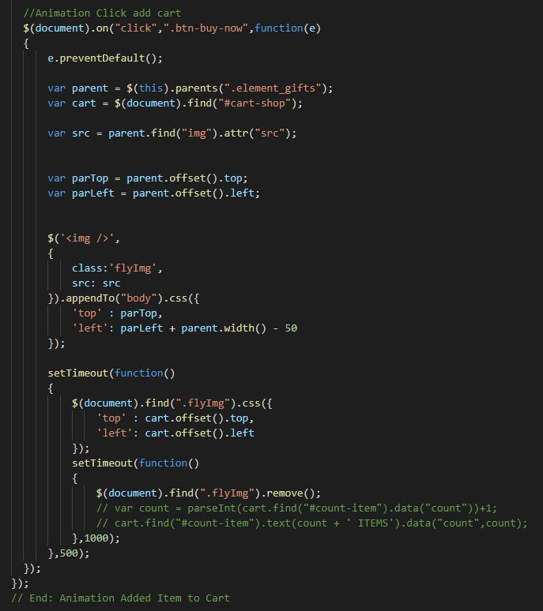

- Contact us javascript
  - Description

This script used for contacting to our customer service.
  - Screenshot

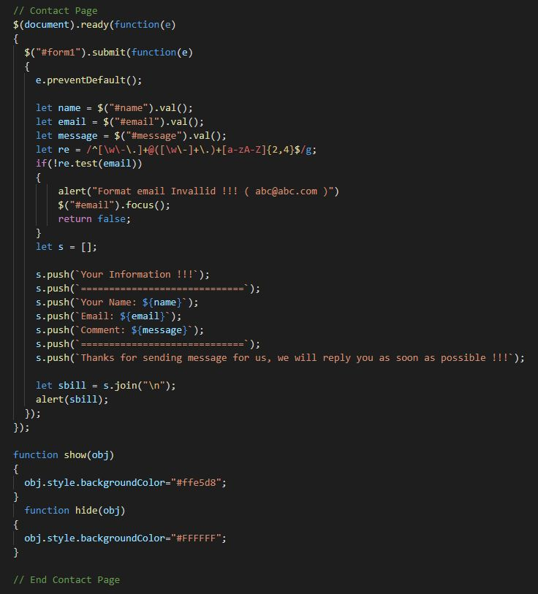
TASK SHEET REVIEW 3

Project Ref. No.:  eP/Advertisement  Portal Management System/01 |  | Project Title: | Activity Plan Prepared By: | Date of Preparation of Activity Plan:
Sr.  No. | Task | Project Title: | Activity Plan Prepared By: | Actual Start Date | Actual Days | Team Mate Names | Status
1 | Website layout | GIFT  SHOP | Đỗ Thành Ân | 20th-July-2021 | 5 | N.H.Tuấn | Completed
2 | Edit CSS | GIFT  SHOP | Đỗ Thành Ân | 20th-July-2021 | 5 | N.H.Tuấn | Completed
3 | Modal javascript | GIFT  SHOP | Đỗ Thành Ân | 23th-July-2021 | 5 | P.Q.N.Thạch | Completed
4 | Filter & comparison javascript | GIFT  SHOP | Đỗ Thành Ân | 23th-July-2021 | 5 | P.Q.N.Thạch | Completed
5 | Product detail and data json | GIFT  SHOP | Đỗ Thành Ân | 20th-July-2021 | 3 | Đ.T.Ân | Completed
6 | Task sheet review | GIFT  SHOP | Đỗ Thành Ân | 06th-Aug-2021 | 3 | Đ.T.Ân | Completed

Date: 06th August 2021
Signature of Instructor:  Ms. Le Mong Thuy | Signature of Team Leader:  Do Thanh An

